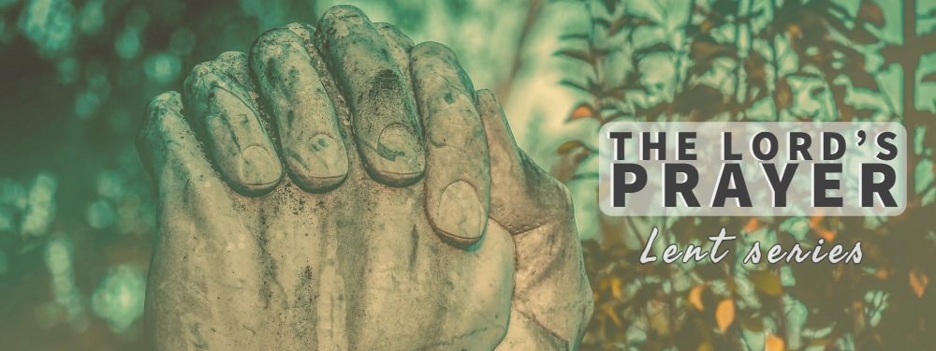
Opening
- What lessons has life experience taught you about forgiveness?
Going Deeper
Read Matthew 6:9-15
- Why do you think commentators describe “forgive us our debts, as we forgive our debtors” as boldest and most demanding petition in the Lord’s prayer?
- How would explain the phrase “forgive us our debts” to someone who is not familiar to the Christian faith?
- What is the significance of the words “us” and “our” in this petition?
- Generally speaking, we tend to downplay our own sins and elevate the sins of others. How does this tendency played out in your life?
- What roll has confession played in your prayer life? How has it helped you face your true self before God?

- Take moment to look at Rembrandt’s The Return of the Prodigal? What stands out to you? If you had to place yourself in the picture, where would you be? Do you find it hard to put yourself in the position of the prodigal? If so, why?
- After teaching this prayer, Jesus elaborates on forgiveness in verse 14-15. How do these words sit with you? How might these verses be teaching us something powerful about God’s grace?
- Reflect on your own web of relationships. Where is their tension and pain? Where might God be inviting you to extend forgiveness right now?
Close in Prayer (we encourage you to give space for silent and spoken confession)
