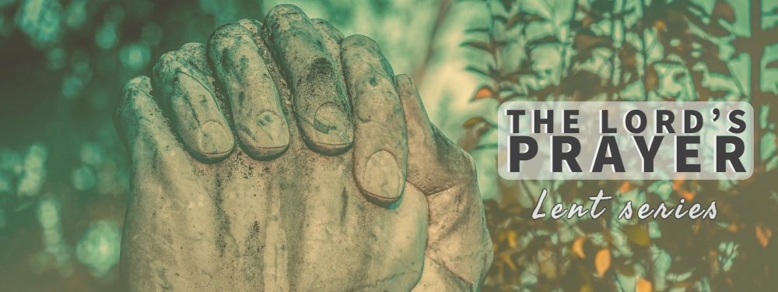
Opening Questions
- Take a moment to watch “Church hunters: Episode 2” on Youtube. What are some weaknesses in the North American Christianity that he is identifying in this episode?
Going Deeper
Read Matthew 6:5-13 together
- Dave mentioned in his sermon that we live in a “my will be done” culture. How do you see this perspective being reinforced in your everyday life in the city?
- Listen to Darrel Johnson’s reflection on our passage: “the older I get, the more I want to pray this third petition of the Lord’s Prayer... I realize now that I do not know how to make life work. There was a time when I thought I did know. But the world is becoming increasingly complex. I look back on a number of turning points in my life, and now rejoice that “my will” was not done.
  - Can you think of times in your own life where this has been true for you?
- What comes to your mind first when you think of the phrase “your will be done on earth as it is in heaven?
  - How does this petition connect to the previous petition, “your kingdom come”?
- Imagine a person comes to worship at Hope for the first time. They’re not sure what to make of the Christian faith yet, and they sit right next to you. After the service, they come up to you and say: “so, Christians believe that they can know God’s will. How exactly do they go about doing this?” What would you say to them?
- How have you discovered the goodness of God’s will in your own life?
- Thinking of key turning points in your life. How have you discerned God’s will in those seasons?
- As Sid mentioned last week, this part of the Lord’s prayer invites believers to submit to God’s revealed will. What does that look like for you right now? What areas might God being inviting you to greater levels of surrender to His will?
Close in Prayer
(feel free to finish with the Lord’s Prayer)

