Small Group Sermon Questions
Sunday, Nov. 25 , 2018
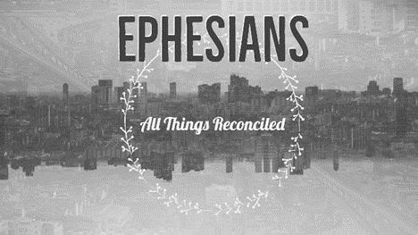
Part 11: The Armor of God – Ephesians 6:10-20

Opening question
- Share a time when you felt really strong. What made you strong then?
- Share a time when you felt powerless. How do you deal with feeling powerless?

Going Deeper Questions

- How do you think the people in Paul’s day felt seeing all the Roman soldiers around them all the time?

- Read Ephesians 6:10-20. How would these people feel when hearing this? How do you feel when hearing it? What piece of the armour do you most desperately need to put on? Why?
- In this passage who are the enemies? Why is it important to take note of that? How are there enemies within us and around us? Name some of the ‘enemies’.

- Read Matthew 5:38-42. How is this a passage about power?

- Why does Paul use the word ‘stand firm’ so often? Why not use the word ‘attack’ sometimes?

- We are the body of Christ. How do we use this armour as the body of Christ together? Go over each piece and describe how we use it.

- Read Hebrews 4:12-16. How does verses 12-13 make you feel? How about when you read the rest of the passage?

- Re-read Eph.6:18-20. Why is prayer so important? What is Paul fighting against in these verses? Why is being ‘alert’ so important? How does that fit with prayer and hearing the Holy Spirit?

- Read Psalm 23:4-5. Sid described how these verses help him enter God’s rest in the midst of battle. How well do you do at ‘resting’ in the midst of your battles? What would that look like?

