Small Group Sermon Questions
Sunday, Nov. 18 , 2018
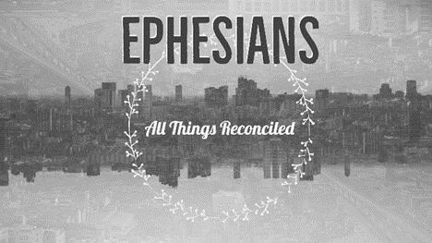
Part 10: The Gospel Enters – Ephesians 5:18-6:10

Opening question
- Share a story about experiencing a different culture. How did it make you feel?
- How do you feel when you have to give in when there’s a disagreement?

Going Deeper Questions

- Read Ephesians 5:18-6:10. What stands out in this passage for you? Why?

- Why is it important to know the cultural context of this passage? What is the cultural context?
- There was a household ‘code’ being described here? What was the family dynamic? How does the gospel story enter this context?

- What is the cultural context for our families today? How does the gospel enter that?

- How is ‘submitting to one another out of love for Christ’ different than just submitting in the culture of that day?

- How has this passage been misused?

- Read Eph. 6:9. Why is it important to note that God doesn’t play favourites? How is this counter-cultural?

- Read Exodus 20:2 and I Kings 5:13 and Eph 5:8. Israel forgot they were slaves at one time. And then we find them acting a lot like the nations around them. Then they found themselves enslaved again in Babylon. How do we do follow the culture in similar ways as Israel did? Why is remembering that we were slaves too so important?

- Read Galatians 3:28. How does this verse help us in our vision for oneness in Christ? How is the communion table such an important reminder of this vision?

- Read 2 Corinthians 3:18. What does this tell us about our transformation and the renewal of all things? Is this comforting to you? Why or why not? How does this help you in all your relationship interactions (marriage, parenting, friendship, employment)

