Small Group Sermon Questions
Sunday, Nov. 11 , 2018
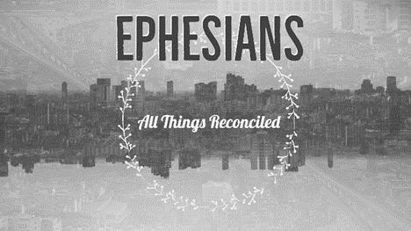
Part 9: From Darkness to Light – Ephesians 5:1-20

Opening question
- Did your family participate in Remembrance Day? How did they do this? How do you feel about Remembrance Day?
- Are there stories in your family of war time experiences? Maybe share a few stories.

Going Deeper Questions

- Read Ephesians 5:1-20. Sid called Ephesians a love letter written in the midst of war. How does that picture fit with this passage?

- In what ways does life at times feel like a battle? What are the ‘battles’ in the passage?
- Read Deuteronomy 30:19-20 and I Peter 2:9. How do these passages fit with vs 15-16 in our Ephesian’s passage?

- Re-read vs 14. Sid talked about how people ‘float’ through life without much focus and reflection; victims of their ‘appetites’. How should we ‘wake up’?

- Paul uses the Greek word, peripateo, six times in chapters 4-6. It means to walk around. What does it mean for you to ‘walk the walk’ of following Christ as opposed to merely ‘talking the talk’?

- Read I Peter 2:9. What is your true identity? How does this effect you? What gets in the way of seeing who we are in Christ?

- Read Ephesians 3:20. A lot of Ephesians 5 is about ‘behaviours’. How is this verse an important reminder?

- What does it mean to ‘always give thanks for everything’. How does Romans 8:28 help you understand this?

- Read I Corinthians 15:55-57 and Isaiah 2:1-4. In the midst of ‘war’ we live in the victory of Christ. How do we live this out? How does this fit with the theme of the renewal of all things?

