Small Group Sermon Questions
Sunday, Sept.30 , 2018
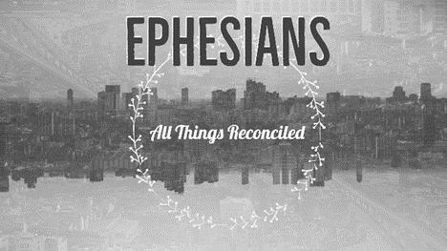

Opening questions
- Share a time when you experienced grace.

- Are you one who easily forgives or not so much? Explain.

Going Deeper Questions

- Read Hebrews 12:15. How come some fail to receive grace? Why is bitterness mentioned in this verse? How are grace and bitterness connected?

- Sid read this quote…”Non believers tend to regard Christians as legions of moral police determined to impose their notion of right behaviours on others.” Is this fair? How has the church helped contribute to this stereotype?
- Read Ephesians 2:1-10. What stands out for you in this passage?

- Paul has experienced grace very personally. How? And how does this allow him to be more gracious?

- “You were dead” but now you’re made “alive”. How were you dead? How are you now alive? Why must you believe both to the core of your being?

- Read Matthew 5:20 and I Peter 2:9. How do these verses deal with grace and works? How can we BE a holy people right now and yet have to exceed the righteousness of the pharisees?

- “The truth, of course, is that holiness is not a human quality like virtue. If there is such a thing at all, holiness is Godness and as such is not something people do but something God does in them, if there is such a thing as God. It is something God seems especially apt to do in people who are not virtuous at all, at least not to start with. Think of Francis of Assisi or Mary Magdalene. Quite the contrary. If you're too virtuous, the chances are you think you are a saint already under your own steam, and therefore the real thing can never happen to you.” How does this quote help you understand grace and works?
- How does thanksgiving fit into the picture? (Charis is Greek for grace and eucharis means thanksgiving. Eucharist is the Lord’s Supper)

