Small Group Sermon Questions
Sunday, Sept.23 , 2018
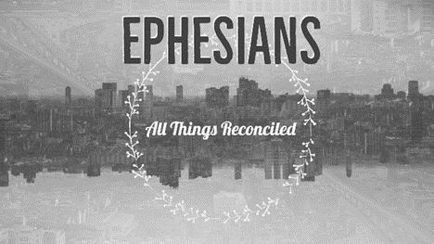

Opening questions
- Share a time when you felt really powerful. Now share a time you felt really weak.

- How do picture power? What comes to mind when you hear the word ‘power’?

Going Deeper Questions

- Read Ephesians 1:15-23 (Read it with some passion) What leaps out at you when you read this passage?

- Paul emphasizes prayer in this passage. Does prayer seem powerful to you? Why or why not?
- Ephesus was a city of power… trade and commerce, the Roman Empire, ‘religious power’… How could we describe Vancouver as a city of power? How does the ‘world’ define power?

- How has the church throughout history misused power?

- How is Paul describing power in this passage? Compare that power to the world’s power. How is ‘kingdom power’ described in scripture?

- Read 2 Corinthians 12:8-10. How is this passage tying together weakness and power? What does this mean to you?

- How is surrender a pathway to power?

- Read I Peter 2:12. How do we do this? What danger is there in “living such good lives”?

- Read Galatians 5:13. How is there ressurrection power in serving? How do you feel when you serve?

- Philip Yancey said, “And then we serve others not with some scheme of making converts, rather to contribute to the common good, to help humans flourish as God intended.” Have you ever noticed bad motivations to serve in your own life or the life of the church? What does Gal.5:13 say the motive for serving is?

- Sid shared the story of Gina Welch as reporter who went ‘undercover’ to explore the world of Christian evangelicals. She didn’t necessarily buy into the beliefs of the church but she was surprisingly drawn by community. What is the power of community?

- Jesus ascended and told the disciples to ‘go and make disciples… to the ends of the earth.’ Somehow we have become the ones who bear the mission of God. Why did Jesus turn over this holy mission to the likes of us? How does that make you feel? What is our power? (read vs 22 again)

- Read verse 17-18 again. What does it mean to you to have the ‘eyes of you heart opened’? Spend some time together in prayer asking the spirit to open your eyes to see what He wants you to see.

