Small Group Sermon Questions
Sunday, May 20 , 2018
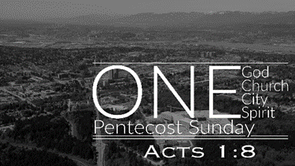
Pentecost 2018
Opening questions
- Share a time where you felt God’s presence deeply.

- How do you picture the Holy Spirit and His work?

Going Deeper Questions

- Do you think we celebrate pentecost sufficiently? Explain.

- Read Acts 2:1-6. What would you be thinking if you were in this crowd?
- Read all of Acts 1. Acts is part 2 of Luke’s writings. How is Jesus the hinge of the two books?

- The disciples asked, ‘is this the time you’ll restore the kingdom of Israel?’ Why did they ask this? What would you have asked Jesus then?

- What would you be thinking while Jesus ascended? Why did He ascend?

- The disciples asked ‘when’. Jesus said that ‘when’ is in the Father’s hands. Why do we get stuck on ‘when’ Jesus will return?

- Read Mark 1:14-15, Luke 17:20-21, Luke 11:20, Luke 13:29. What is the Kingdom like? How do you picture the Kingdom? How do we distort the way the kingdom is?

- Read Acts 1:8. What does this passage say to us? How will you do that where you are?

- Read Acts 1:11. How are we in danger of spectating instead of witnessing?

- Read James 2:15-17. What do these verses say about the kingdcom come?

- The Kingdom vision immediately got practical. They gathered, prayed, pick leaders and went out. Read Acts 2:42-47. What else did they do? How should we as a church practically live out this Kingdom vision?

