Small Group Sermon Questions
Sunday, May 13 , 2018
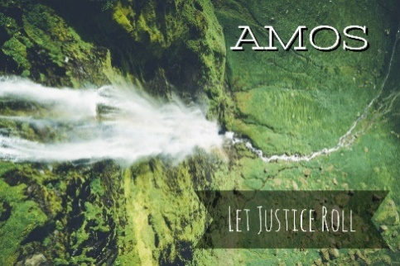
Amos series: Let Justice Roll Part 6: The Plumbline
Opening questions
- If someone says, ‘I’ve got good news and bad news’. Which one do you want to hear first? Why?

- What’s one of the hardest things you’ve ever had to tell someone?

Going Deeper Questions

- Read Amos 7:1-15. How do you understand and deal with the whole idea of God’s judgement? How does the book of Amos help you understand?

- How does the message of Amos speak to our time and place?
- In Amos 7 where do we see God’s patience? How does Psalm 103:2-12 help you understand Amos 7?

- Why is it good that God holds the plumb line?

- In the message, Sid said that part of Israel’s problem is that they forgot they were once slaves. How is that important? Read Romans 3:23-24. How does this passage help?

- Read Micah 7:18 and Amos 7:8. How do the ideas about ‘passing over’ in these verses fit together?

- How did the false priest, Amaziah, describe the temple in verse 13? What does this tell us? How are we in danger of doing the same?

- Jesus said, ‘be in the world but not of it’. How are we to be in culture but not of it? How is this different than just slamming culture all the time?

- Israel made their ‘religion’ and culture more important than obeying God. How willing are you to hear hard words from God about your life?

- Read Amos 9:14-15 and Micah 7:18-19. There still hope. How is that hope shown to Israel? What is the lasting hope found in Romans 5:6-10?

- Read Isaiah 40:3-5 What does it mean for us individually and as church to make things ‘straight’?

