Small Group Sermon Questions
Easter Sunday, April 1, 2018
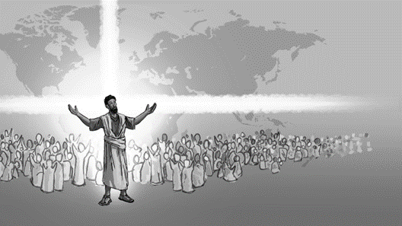
Images of the Cross Part 3: Christ our Reconciler
Opening questions
- What do you celebrate better – Easter or Christmas? Why?

- How did your family celebrate Easter?

Going Deeper Questions

- Sid shared how scripture is the story of a God who never gives up. How have you seen this in your own life?

- “Christ has risen!” What does this phrase do to you emotionally? What impact on life does this have?
- Read Colossians 1:15-23. How does this amazing poem impact you? How is it a poem of rebellion?

- Paul talks about reconciliation in the poem. What does that mean? What will be reconciled? How does that change the way we live and the way we view salvation?

- Is your Easter big enough? Explain.

- Paul wrote to people being pulled by their cultural ideas, one of them being Gnosticism which diminished the value of the physical. Paul pulls them back to the supremecy of Christ crucified and risen bodily. What cultural ideas do we get ‘pulled’ toward? How does Christ’s supremecy overcome those ideas?

- What broken places do you need to bring this reconciling gospel to?

- Read verses 21-23 again. What are “YOU” suppose to do? (note the you’s in this passage)

- How do you keep yourself living in this Easter reality each and every day?

- How does the graphic speak to you?

