Small Group Sermon Questions
Sunday, March 11, 2018
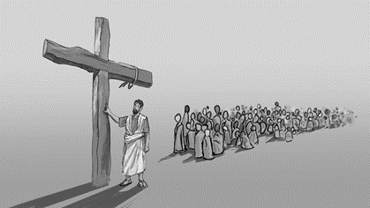
Images of the Cross Part 2: Christ our Representative
Opening questions
- If you had to choose to pick someone to play you in a movie who would it be? Why?

- Pick one object that would represent you and tell why.

Going Deeper Questions

- Read Romans 5:12-21. What about this passage strikes you the most?

- I Cor. 15:21-22 Why is Adam our representative? Does this seem unfair to you?
- What does Paul mean by death in these two passages?

- What did Augustine mean when he said, ‘we are sinners by birth and by choice’?

- The religious leaders placed their identity as children of Abraham. Why did they do that and why does Paul push them back to Adam? Where do you tend to put your identity? Why do you need to go back to Adam too?

- Read Romans 8:31-39 How do we attain this identity of a ‘conqueror’?

- Read John 3:1-6 and Psalm 51:5-10. Why is birth the curse and the cure?

- Read Genesis 3:1-6 and then read Matthew 26:36-42. Compare these two garden stories. Why does one lead to death and the other to life? What was the key to life?

- On the cross Jesus cries out ‘it is finished’. What is finished? How does Romans 5:17 show this?

- Read 2 Cor.5:17-21. How do we become Christ’s representatives? How does this make you feel?

