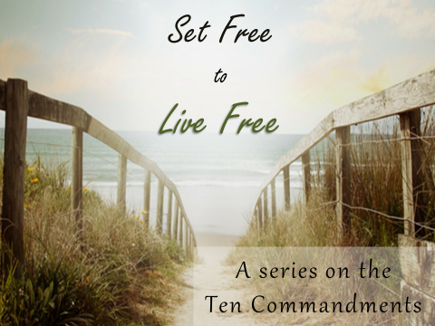
Part 8: Kleptomania
Galatians 3:24 “So then, the law was like a tutor, assigned to train us and point us to the Anointed, so that we will be acquitted of all wrong and made right by faith.”
Romans 8:1-4 “There is therefore now no condemnation for those who are in Christ Jesus] ² For the law of the Spirit of life has set you free in Christ Jesus from the law of sin and death. ³ For God has done what the law, weakened by the flesh, could not do. By sending his own Son in the likeness of sinful flesh and for sin] he condemned sin in the flesh, ⁴ in order that the righteous requirement of the law might be fulfilled in us, who walk not according to the flesh but according to the Spirit.”
Exodus 20:15 “You shall not steal.”
Exodus 22:1 “If a man steals an ox or a sheep, and kills it or sells it, he shall repay five oxen for an ox, and four sheep for a sheep.”
Luke 19:8 “ But Zacchaeus stood up and said to the Lord, “Look, Lord! Here and now I give half of my possessions to the poor, and if I have cheated anybody out of anything, I will pay back four times the amount.”
Matthew 21:13-14 “ Jesus went straight to the Temple and threw out everyone who had set up shop, buying and selling. He kicked over the tables of loan sharks and the stalls of dove merchants. He quoted this text:My house was designated a house of prayer; You have made it a hangout for thieves.”
2 Samuel 12:1-9 “ David became very angry at the rich man. He said to Nathan, “As surely as the Lord lives, the man who did this should die! ⁶ He must pay for the lamb four times for doing such a thing. He had no mercy!”⁷ Then Nathan said to David, “You are the man! This is what the Lord, the God of Israel, says: ‘I appointed you king of Israel and saved you from Saul. ⁸ I gave you his kingdom and his wives. And I made you king of Israel and Judah. And if that had not been enough, I would have given you even more. ⁹ So why did you ignore the Lord’s command? Why did you do what he says is wrong? You killed Uriah the Hittite with the sword of the Ammonites and took his wife to be your wife!”
Psalm 24:1 “The earth is the Lord’s, and all its fullness, The world and those who dwell therein.”
- The ____________ come from Yahweh’s ____________
Exodus 23:11 “during the seventh year let the land lie unplowed and unused. Then the poor among your people may get food from it, and the wild animals may eat what is left. Do the same with your vineyard and your olive grove.”
- We are not ____________ but ____________
Malachi 3:8 “ Will someone steal from God?” Yet you are always stealing from Me! But you self-centered people still ask, “How have we stolen from You?” In the tithes and the offerings you have not given Me as the law requires!
- To NOT let the blessings become a blessing is to ____________ the blessing.
Deuteronomy 8:11-17 “ But then be very careful! Don’t forget the Eternal your God and disobey the commands and decrees and rules I’m giving you today. ¹² When your stomachs are full, when you’ve built comfortable houses to live in, ¹³ when you have large herds and flocks, when you possess plenty of silver and gold, and when you have more things than you imagined possible; ¹⁴ then don’t become proud and puffed up and forget Him. He brought you out of the land of Egypt where you were slaves; ¹⁵ and He led you through that awful, vast wilderness with its poisonous snakes and scorpions, through that desert where there was no water. He made water come out of a hard rock; ¹⁶ and He fed you in the wilderness with manna, a food your ancestors had never heard of. He did all this to humble you and test you, but it was all intended for your good in the end. ¹⁷ If He hadn’t, you might have believed, “I’ve gotten all this wealth by my own power and strength!”
I Timothy 6:17 “Command those who are rich in this present world not to be arrogant nor to put their hope in wealth, which is so uncertain, but to put their hope in God, who richly provides us with everything for our enjoyment.”
- Our feelings about our possessions is a very accurate indicator of _________________________
Psalm 23:1 “The Lord is my shepherd, I lack nothing.”
Philippians 4:19 “ And my God will meet all your needs according to the riches of his glory in Christ Jesus.”
Hebrews 13:5-6 “Keep your lives free from the love of money and be content with what you have, because God has said, “Never will I leave you; never will I forsake you.”⁶ So we say with confidence, “The Lord is my helper; I will not be afraid.”
Romans 8:31-32 “What, then, shall we say in response to these things? If God is for us, who can be against us? ³² He who did not spare his own Son, but gave him up for us all—how will he not also, along with him, graciously give us all things?”
Answers and order:
Slide one when I come up
Luke 19
Slide 2
Psalm 24:1
Slide 3
The commands come from Yahweh’s character
Exodus 23:11
We are not owners but stewards
Malachi 3
Slide 4
To NOT let the blessings become a blessing is to steal the blessing.
I Timothy 6
Our feelings about our possessions is a very accurate indicator of spiritual vitality

