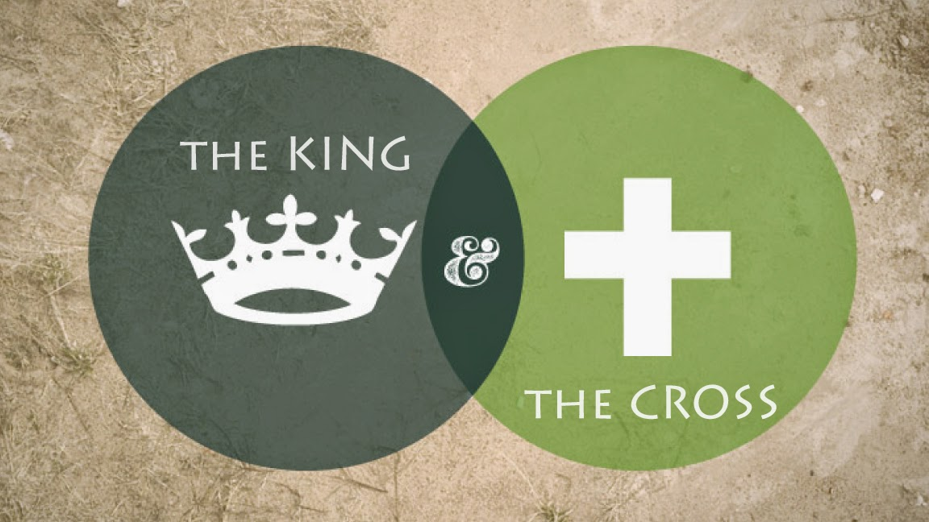
Part 2: The Healing
- Mark’s gospel is the ____________ in ____________
Mark 1:1 “The beginning of the good news about Jesus the Messiah, the Son of God,…”
Mark 1:14-15 “After John was put in prison, Jesus went into Galilee, proclaiming the good news of God. ¹⁵ “The time has come,” he said. “The kingdom of God has come near. Repent and believe the good news!”
Mark 1:35-38 “Very early in the morning, while it was still dark, Jesus got up, left the house and went off to a solitary place, where he prayed. ³⁶ Simon and his companions went to look for him, ³⁷ and when they found him, they exclaimed: “Everyone is looking for you!”³⁸ Jesus replied, “Let us go somewhere else—to the nearby villages—so I can preach there also. That is why I have come.” ³⁹ So he traveled throughout Galilee, preaching in their synagogues and driving out demons.”
- ____________ without _____________ quickly becomes about you.
John 16:33 ““I have told you these things, so that in me you may have peace. In this world you will have trouble. But take heart! I have overcome the world.”
Mark 2:1-6 “A few days later, when Jesus again entered Capernaum, the people heard that he had come home. ² They gathered in such large numbers that there was no room left, not even outside the door, and he preached the word to them. ³ Some men came, bringing to him a paralyzed man, carried by four of them. ⁴ Since they could not get him to Jesus because of the crowd, they made an opening in the roof above Jesus by digging through it and then lowered the mat the man was lying on. ⁵ When Jesus saw their faith, he said to the paralyzed man, “Son, your sins are forgiven. ⁶ Now some teachers of the law were sitting there, thinking to themselves, ⁷ “Why does this fellow talk like that? He’s blaspheming! Who can forgive sins but God alone?”
- Our real problem is that every one of us is building our ____________ on something besides ____________.
Romans 7:15-18 “I do not understand what I do. For what I want to do I do not do, but what I hate I do…As it is, it is no longer I myself who do it, but it is sin living in me. ¹⁸ For I know that good itself does not dwell in me, that is, in my sinful nature. For I have the desire to do what is good, but I cannot carry it out.
Hosea 6:1-2 (The Voice) ” Come on, let’s renew our loyalty to the Eternal One! He tore us like a lion, but He’ll heal us; He wounded us, but He’ll bandage us.² He’ll bring us back to life after two days; He’ll raise us up on the third day, and we’ll live with Him.”
Hebrews 4:12-13(the Voice) “The word of God, you see, is alive and moving; sharper than a double-edged sword; piercing the divide between soul and spirit, joints and marrow; able to judge the thoughts and will of the heart. ¹³ No creature can hide from God: God sees all. Everyone and everything is exposed, opened for His inspection; and He’s the One we will have to explain ourselves to.”
Galatians 2:20 “ I have been crucified with Christ and I no longer live, but Christ lives in me. The life I now live in the body, I live by faith in the Son of God, who loved me and gave himself for me.”

Answers and order:
Slide 1 and 2
Mark’s gospel is the Kingdom in action
Action without prayer quickly becomes about you.
Our real problem is that every one of us is building our identity on something besides Jesus
Slide 3 and 4
Romans 7 and the other verses

