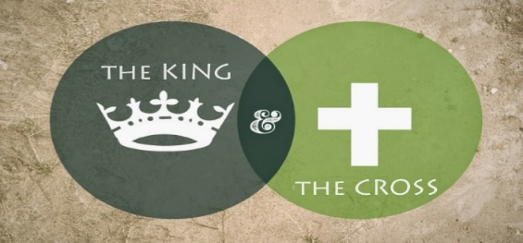 Part 13: The Cup
Mark 14:32-42 “They went to a place called Gethsemane, and Jesus said to his disciples, “Sit here while I pray.” ³³ He took Peter, James and John along with him, and he began to be deeply distressed and troubled. ³⁴ “My soul is overwhelmed with sorrow to the point of death,” he said to them. “Stay here and keep watch.”³⁵ Going a little farther, he fell to the ground and prayed that if possible the hour might pass from him. ³⁶ “Abba, Father,” he said, “everything is possible for you. Take this cup from me. Yet not what I will, but what you will.” ³⁷ Then he returned to his disciples and found them sleeping. “Simon,” he said to Peter, “are you asleep? Couldn’t you keep watch for one hour? ³⁸ Watch and pray so that you will not fall into temptation. The spirit is willing, but the flesh is weak.”³⁹ Once more he went away and prayed the same thing. ⁴⁰ When he came back, he again found them sleeping, because their eyes were heavy. They did not know what to say to him.⁴¹ Returning the third time, he said to them, “Are you still sleeping and resting? Enough! The hour has come. Look, the Son of Man is delivered into the hands of sinners. ⁴² Rise! Let us go! Here comes my betrayer!”
Genesis 2618 “So early the next morning Jacob took the stone he had put under his head, set it up as a pillar, and then poured oil on top of it to commemorate his experience with God.”
Exodus 27:20 “ Direct the Israelites to bring you oil from olives whipped until it is clear in order to keep the lamps burning continually and producing the best light possible.”
Isaiah 61:1 “The Spirit of the Lord, the Eternal, is on me. The Lord has appointed me for a special purpose. He has anointed me to bring good news to the poor. He has sent me to repair broken hearts, And to declare to those who are held captive and bound in prison, “Be free from your imprisonment!”
Luke 22:44 “And in His anguish, He prayed even more intensely, and His sweat was like drops of blood falling to the ground.”
Hebrews 4:15-16 “For our high priest is able to understand our weaknesses. He was tempted in every way that we are, but he did not sin. ¹⁶ Let us, then, feel very sure that we can come before God’s throne where there is grace. There we can receive mercy and grace to help us when we need it.”
Romans 8:31, 37-38 “What, then, shall we say in response to these things? If God is for us, who can be against us? ³² He who did not spare his own Son, but gave him up for us all—how will he not also, along with him, graciously give us all things?... ³⁷ No, in all these things we are more than conquerors through him who loved us. ³⁸ For I am convinced that neither death nor life, neither angels nor demons, neither the present nor the future, nor any powers, ³⁹ neither height nor depth, nor anything else in all creation, will be able to separate us from the love of God that is in Christ Jesus our Lord.”
Jeremiah 24:7 “I will give them a heart to know me, that I am the Lord. They will be my people, and I will be their God, for they will return to me with all their heart.”
Matthew 28:20 “…teaching them to obey everything I have commanded you. And surely I am with you always, to the very end of the age.”

Communion
Exodus 6:6-7 “Moreover, I have heard the groaning of the Israelites, whom the Egyptians are enslaving, and I have remembered my covenant.⁶ “Therefore, say to the Israelites: ‘I am the Lord, and I will bring you out from under the yoke of the Egyptians. I will free you from being slaves to them, and I will redeem you with an outstretched arm and with mighty acts of judgment. ⁷ I will take you as my own people, and I will be your God. Then you will know that I am the Lord your God, who brought you out from under the yoke of the Egyptians.”

Psalm 116:12-13 “What shall I return to the Lord for all his goodness to me? ¹³ I will lift up the cup of salvation
and call on the name of the Lord.
I Corinthians 10:16-17 “When we give thanks and share the cup of blessing, are we not sharing in the blood of the Anointed One? When we give thanks and break bread, are we not sharing in His body? ¹⁷ Because there is one bread, we, though many, are also one body since we all share one bread.”

Order of slides
Slide 1
Mark 14:32-42
Hebrews 4
Slide 2
Communion
Exodus 6
Slide 3
Slide 4

