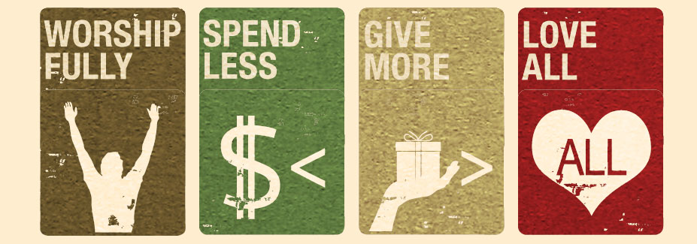
Advent Conspiracy: Part 3 – Love All
John 1:1-5,9-14 “In the beginning was the Word, and the Word was with God, and the Word was God. ² He was with God in the beginning. ³ Through him all things were made; without him nothing was made that has been made. ⁴ In him was life, and that life was the light of all mankind. ⁵ The light shines in the darkness, and the darkness has not overcome it…⁹ The true light that gives light to everyone was coming into the world. ¹⁰ He was in the world, and though the world was made through him, the world did not recognize him. ¹¹ He came to that which was his own, but his own did not receive him. ¹² Yet to all who did receive him, to those who believed in his name, he gave the right to become children of God— ¹³ children born not of natural descent, nor of human decision or a husband’s will, but born of God.¹⁴ The Word became flesh and made his dwelling among us. We have seen his glory, the glory of the one and only Son, who came from the Father, full of grace and truth.”
James 1:16-17 “ Don’t be deceived, my dear brothers and sisters. ¹⁷ Every good and perfect gift is from above, coming down from the Father of the heavenly lights, who does not change like shifting shadows.”
I John 4:19-21 “ We love because he first loved us. ²⁰ Whoever claims to love God yet hates a brother or sister is a liar. For whoever does not love their brother and sister, whom they have seen, cannot love God, whom they have not seen. ²¹ And he has given us this command: Anyone who loves God must also love their brother and sister.”
Mark 10:17-22 (The Message) ““Good Teacher, what must I do to get eternal life?”¹⁸⁻¹⁹ Jesus said, “Why are you calling me good? No one is good, only God. You know the commandments: Don’t murder, don’t commit adultery, don’t steal, don’t lie, don’t cheat, honor your father and mother.”²⁰ He said, “Teacher, I have—from my youth—kept them all!”²¹ Jesus looked him hard in the eye—and loved him! He said, “There’s one thing left: Go sell whatever you own and give it to the poor. All your wealth will then be heavenly wealth. And come follow me.”²² The man’s face clouded over. This was the last thing he expected to hear, and he walked off with a heavy heart. He was holding on tight to a lot of things, and not about to let go.”

Slide one before the verses

