Small Group Sermon Questions
Sunday, November 12, 2017
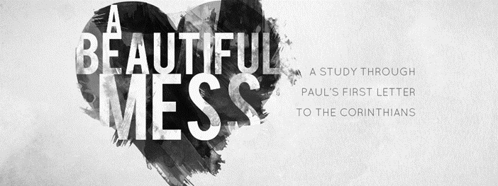
Part 9: I Corinthians 13- The Point of it All
Opening questions
- When was the first time you thought you were ‘in love’. How did that turn out?

Going Deeper Questions

- Read I Corinthians 12:31-I Cor.13. Share your intial thoughts on this passage. What makes it the ‘most excellent way’?
- In one version of the Bible it says this most excellent way is a way beyond comparison. How would this fit the context of the Corinthian church? How does it help us?

- How come all the gifts mentioned in vs 1-3 amount to nothing without love? Surely some good must come from those amazing gifts.

- What are the 16 verbs Paul uses to show what love looks like? Which one challenges you the most?

- Read Romans 12:9-12. What does sincere love look like? How does this challenge you?

- How do feelings mess with ‘deep love’? Sid described love as a ocean. He said most stay knee deep instead of taking the plunge. Why do we resist plunging in?

- “Love is risky.” Do you agree? Why/why not?

- I Cor.13:12. The Corinthians were famous for their polished metal mirrors. The images weren’t particularly clear. Why is Paul using this mirror metaphor? How does this effect the way we love and relate?

- English only has one word for love. The Greeks used four: Strorge: affection toward anything you enjoy; Phileo - friendship- affection to those I share interests with; Eros- romantic desires towards someone I crave; Agape: divine love. A young couple comes to you for some advice on being married. How do you help them see that marriage is about moving from eros to agape? How do you move toward deeper love in your life? What holds you back?

