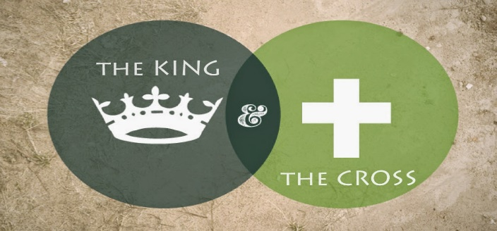
Part 4: The Power
Mark 4:35-38 “ That day when evening came, he said to his disciples, “Let us go over to the other side.” ³⁶ Leaving the crowd behind, they took him along, just as he was, in the boat. There were also other boats with him. ³⁷ A furious squall came up, and the waves broke over the boat, so that it was nearly swamped. ³⁸ Jesus was in the stern, sleeping on a cushion. The disciples woke him and said to him, “Teacher, don’t you care if we drown?”
Mark 4:39-41 “ He got up, rebuked the wind and said to the waves, “Quiet! Be still!” Then the wind died down and it was completely calm.⁴⁰ He said to his disciples, “Why are you so afraid? Do you still have no faith?”¹ They were terrified and asked each other, “Who is this? Even the wind and the waves obey him!”
Psalm13:1-2 “How long, Lord? Will you forget me forever? How long will you hide your face from me? ² How long must I wrestle with my thoughts and day after day have sorrow in my heart?”
Matthew 28:20 “Teach them to observe all that I have commanded you and, remember, I am with you always, even to the end of the world.”
I Samuel 4:2-3 “Israel was defeated by the Philistines, who killed about four thousand of them on the battlefield. ³ When the soldiers returned to camp, the elders of Israel asked, “Why did the Lord bring defeat on us today before the Philistines? Let us bring the ark of the Lord’s covenant from Shiloh, so that he may go with us and save us from the hand of our enemies.”
Isaiah 55:8 ““For my thoughts are not your thoughts, neither are your ways my ways,” declares the Lord.
⁹ “As the heavens are higher than the earth, so are my ways higher than your ways and my thoughts than your thoughts.”
Psalm 63:7-8 “Because you are my help, I sing in the shadow of your wings.⁸ I cling to you; your right hand upholds me.”
Matthew 17:20 “Truly I tell you, if you have faith as small as a mustard seed, you can say to this mountain, ‘Move from here to there,’ and it will move. Nothing will be impossible for you.”
Mark 9:24 “ Immediately the boy’s father exclaimed, “I do believe; help me overcome my unbelief!”
Revelations 21:3-5 “ And I heard a loud voice from the throne saying, “Look! God’s dwelling place is now among the people, and he will dwell with them. They will be his people, and God himself will be with them and be their God. ⁴ ‘He will wipe every tear from their eyes. There will be no more death’ or mourning or crying or pain, for the old order of things has passed away.”⁵ He who was seated on the throne said, “I am making everything new!”
Isaiah 43:1-3 “But now, this is what the Lord says— he who created you, Jacob, he who formed you, Israel:
“Do not fear, for I have redeemed you; I have summoned you by name; you are mine. When you pass through the waters, I will be with you; and when you pass through the rivers, they will not sweep over you.
When you walk through the fire, you will not be burned; the flames will not set you ablaze.³ For I am the Lord your God,…”

